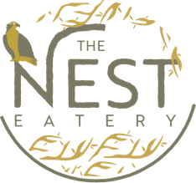

Event:
Hava’s 50th Birthday

Date/Time:
December 31st, 2022 / 8pm-1am

Station 1:
Crudité – Hummus, garlic hummus, tahini, carrots, cucumbers, cherry tomatoes, pita bread, celery, variety crackers
Assortment - Kalamata olives, diced tomatoes, gouda, cheddar, feta

Station 2:
Vegetarian ziti – (No meat of chicken stock)
Guacamole cucumber cups – Cucumber rounds scooped out, guacamole, pinch of chili powder
Caprese skewers – Skewered cherry tomatoes, mozzarella, basil, balsamic drizzle
Garlic parmesan potato wedges

Station 3:
Greek flatbread – Hummus, pesto, tomato, red onion, artichoke hearts, feta, arugula
Marinara flatbread – Olive oil, marinara, mozzarella, tomatoes, basil
Brie & fig flatbread – Fig jam, brie, balsamic, arugula, caramelized onion

